



**Motorcycle**

**Training Guide**

**Introduction**

The origins of the RoSPA Advanced Drivers' Association (RoADA) go back to 1955. At that time, a lady called Louise Duncan who was the road safety officer for the Borough of Finchley felt that she should try to do something about the rising tide of road accidents. She was very impressed by the standard of training and testing at the Police driving school in the nearby borough of Hendon and felt that some form of training and testing along these lines would be a great help for ordinary drivers.

With the help of a number of instructors from the police driving school, she formed the Finchley League of Safe Drivers. Members of the public could join the group, attend lectures and get advice on their driving, leading to a test. The group proved popular and, by 1960, had spread nationwide, becoming the League of Safe Drivers. In many parts of the country, local groups were formed to enable candidates to prepare for the test.

By 1980, the League had become large and management was proving difficult. RoSPA, who had always assisted the league, agreed to take over the management and it became the RoSPA League of Safe Drivers. In 1992, at the request of its members, it became the RoSPA Advanced Drivers' Association; however, in 2006 to reflect the diversity of tests; became known as RoSPA Advanced Drivers & Riders.

The Society’s advanced test remains unique in that it is the only advanced test to be graded and the only one where its members are asked to retake their test triennially.

To help drivers and riders prepare for the advanced test there is a network of local RoADAR groups located throughout the United Kingdom, run entirely by volunteers who provide free help and advice to their members.

The tuition that local Groups provide is on a one-to-one or one-to-two basis using the member’s own vehicle under the guidance of experienced Group tutors. Although there is no limitation on the number of lessons provided, it is not unusual for between twelve and twenty lessons to be taken before most members feel sufficiently prepared for their initial test. After the initial test, tuition is provided as and when requested on the lead-up to any triennial retest.

Tuition

All Group tutors are registered with the RoADAR having passed their tests at the higher levels and every effort is made to ensure that the tuition provided takes cognisance of the individual, their needs, abilities and experience.

Motorcycle tutors however, unlike car tutors who use the trainee’s vehicle, incur cost because they use their own vehicle. Subsequently, the motorcycle trainees may be requested to recompense their tutor’s expenses for each lesson.

Before tuition begins we we will supply a copy of Roadcraft the Police Rider’s handbook to better Motorcycling and The Highway Code

This Guide to Tuition ought to be regarded as supplemental to these official publications and has been produced simply to reinforce the various advanced techniques introduced in Roadcraft, help underpin some of the essential aspects of advanced riding generally and act as an aid to tuition.

#### IMPORTANT INFORMATION

#### FOR GROUP MEMBERS UNDERTAKING TUITION

**You must be the holder of a full licence for the class of vehicle, and the vehicle must be insured against third party risks and, if applicable, have a current M.o.T. certificate.**

**During tuition you are deemed to be responsible for your own actions while riding and to be in full control of your vehicle at all times.**

**Any advice or instruction given by your tutor, which you feel is unsafe for you to carry out, must be ignored and you should only do what you believe to be safe.**

**What Is Advanced Motorcycle Riding**

ADVANCED RIDING is the ability to control the position and speed of the vehicle safely, systematically and smoothly, using road and traffic conditions to progress unobtrusively with skill and responsibility.

This skill requires a positive but courteous attitude and a high standard of riding competence based on concentration, effective all round observation, anticipation and planning. This must be co-ordinated with good handling skills.

The vehicle should be at the right place on the road at the right time, travelling at the right speed with the correct gear engaged and can always be stopped safely on its own side of the road in the distance that can be seen to be clear.’

While the official definition is given above, advanced or defensive riding is quite simply the art of road accident prevention and an advanced rider does this by anticipating and positively controlling situations to reduce their crash risk and is a deliberate, skilful and responsible technique admired by others.

The ability to perceive, grade and assess a hazard and anticipate any danger, actual or potential, equips advanced riders with the skills to avoid those zones of danger, as opposed to using their skills simply to get out of them. It also gives them the essential benefit of space and time, which enables them to react to the inappropriate actions of others by good planning.

**Becoming A Better Rider**

Roadcraft:

To reach this desired state will not happen overnight. Depending on individual ability, experience and overcoming the natural resistance to learning that is common in us all, may require many hours of study and practice.

The perfect rider hasn’t been nor ever will be born. However, that shouldn’t deter anyone from striving for that perfection. Throughout your tuition you will be taught the techniques of ‘system’ riding. If you systematically eliminate your riding faults and react to the tuition given, you will be well prepared for not only your initial test, but for the triennial advanced tests that lie ahead.

Concentration and alertness are key aspects of good riding which are strongly influenced by our general health, medication, fatigue and emotional state. Prior to riding you should ensure that you are fit to ride. A useful acronym to help you remember this is I AM SAFE:

Infection: Are you suffering from infection / illness which affects ability to concentrate.

Attitude: Are you focused and comfortable about making this journey.

Medication: Are you taking medication that makes you drowsy or unable to concentrate.

Sleep: Have you had sufficient sleep and are not feeling tired.

Alcohol: Are you under the influence of alcohol or drugs.

Food: Have you had sufficient food and water and are not dehydrated.

Emotions: Are you feeling angry, sad or depressed.

**Learning new riding skills is a continuous process. It involves reviewing, adapting and updating your skills to keep pace with the ever changing and increasingly complex traffic environment. Remember; good riders never stop learning**.

**Pre-Ride Roadworthiness Checks**

A full pre-ride and roadworthiness safety check is only required before the machine is ridden for the first time that day, thereafter an abridged version may be carried out each time the rider uses the vehicle throughout the day. *(See Starting Drill)*

A useful acronym to help you remember this is **POWDDERSS:**

|  |  |
| --- | --- |
| **P**etrol: | Check for leaks and sufficiency for the journey.  Plan refuelling stops. |
| **O**il: | Which includes Front and Rear hydraulic fluid levels (brake and clutch) engine oil and suspension components.  Check when cold and on a level surface that the settings are correct. |
| **W**ater: | Check coolant level is correct on a level surface. |
| **D**amage:  **D**rive : | Machines do not have a protective body so stone chips and other damage could affect safety and operating systems.  Inspect drive chain/sprockets or shaft etc for tension, lubricant/leaks.  If in doubt check it out. |
| **E**lectrics: | Ensure all lights, indicators and horn are working and that the battery is being charged. |
| **R**ubber: | Check tyres for pressure, tread and damage including the wheel rims. |
| **S**teering:  **S**uspension: | Check free movement of the steering head and excess bearing wear  Check suspension settings and oil seals of leakage |

The check sequence should be a methodical and systematic routine to ensure that your vehicle is fit for the purpose of your daily ride and commences as you walk towards your machine with a visual inspection of the vehicle and the ground beneath it for any signs of damage and leaking fluids.

For the purposes of the advanced test, it may be assumed that the test is the first time that the vehicle has been ridden that day, therefore a full pre-ride and roadworthiness safety check may require to be demonstrated.

A typical example of a pre-ride check commentary is as follows:

This is my XYZ motorcycle and I am fully familiar with its instruments and the controls of which have been suitably adjusted for my comfort and ease of use. The mirrors are adjusted to afford me good visibility to the side and rear with the subsequent blind spot being visible with a right and left shoulder check.

A check of the fuel gauge / tank confirms I have enough fuel for my journey (or I am planning to make an early fuel stop). A check of the dipstick / sight-glass shows the oil is at the correct level, as is the hydraulic fluid for both front and rear brakes, (and clutch if applicable). The water level (if applicable) is correct and a visual check around the machine reveals no damage to fairing or other parts, all glass is clean.

I am now checking the steering by moving the front wheel from lock to lock. This will indicate if there is any wear in the steering bearings and also if any of the control cables are snagging.

I shall now inspect and rotate the front wheel and tyre for signs of wear, regular or uneven, any cuts, rips, tears or any stones, screws, nails or other alien objects in the tyre or wheel and check the front suspension for any fluid leaks or seal damage. Moving to the rear of the machine I shall now check the rear wheel and tyre (as for the front). The pressure for the front and rear tyres are..?? psi.

Finally I shall check the chain (if fitted). It is adjusted to the manufacturer’s recommendations, well lubricated with no tight spots.

I am now going to check the electrics; turning on the ignition reveals the pre-programmed electronic checks ending with ‘normal’ dashboard warning lights. I expect the ignition and oil warning lights to extinguish when I start the engine. I am now going to start the engine and note the neutral light warning light is lit.

I am now carrying out a static brake test on the front and rear brakes to ensure that the system is pressurised and that the rear brake light operates correctly when both hand / foot levers are depressed / released.

I am now going to check:

1. Indicators, left, right, front and rear. All are operational.
2. Sidelight, dipped headlight, main beam and headlamp flasher. All are operational.
3. Rear light, operational with sidelight, dipped headlight or main beam.
4. Horn is working correctly.

**Starting Drill**

Before using a vehicle and setting off it is important that the rider ensures they have good access to hand and foot controls and that the controls are set correctly. To this end there is a starting drill, which should be carried out by the rider each time they take the controls of a vehicle.

**Bike: Supported On Centre Stand**

1. Approach machine from the nearside, insert ignition key and disengage steering lock. *(Check and remove / disengage any other ‘anti theft’ devices / alarms)*
2. Left hand locates the left handlebar, right hand locates the right handlebar and cover both the brake and clutch levers.
3. Standing close to machine with your left foot in front of the centre stand, gently rock the machine off the stand ensuring that the stand is fully retracted.
4. As machine drops from stand, angle the handlebars towards you and apply the front brake.
5. With a good footing under the left foot, locate, extend and lock the side stand into position.
6. Gently lean the machine over ensuring that it is securely support by the side stand.

**Bike: Supported On Side Stand**

1. Approach machine from the nearside, insert ignition key and disengage steering lock.*(Check and remove / disengage any other ‘anti theft’ devices / alarms)*
2. Left hand located on the handlebar and right hand applying the front brake, angle the handlebars towards you.
3. With good footing under the left foot, pivot on to the machine without putting undue weight on the side stand.
4. With your right foot firmly placed on the ground, raise the machine upright and turn the handlebars to the straight ahead position.
5. Retract the side stand with your left foot, ensuring it’s fully retracted.
6. Place your left foot on the ground and your right foot on the foot brake.
7. Ensure you have a comfortable seating position with good access to all foot and hand controls.
8. Switching on the ignition with the right hand, ensure the neutral light is on *(if necessary select neutral to achieve this)* and with the clutch lever pulled in to disengage the clutch, start the engine and then slowly release the clutch lever.
9. Select auxiliaries required for the journey.
10. Check nearside and offside mirrors provide a good view down both sides and to the rear of the machine.
11. Check instrument panel is ‘Normal’.
12. Carry out a static brake test applying pressure to both front and rear brakes for 3 to 4 seconds. Confirm there is pressure in the system and it can be maintained. Keep pressure on the rear brake. *(Report that you have, earlier today, carried out a moving brake test on this machine and that the brakes are operating correctly on both road wheels.)*
13. You are now ready to move off.

**Resume**

Today as all days I shall ride my motorcycle according to the ‘System of Motorcycle Control’, which is a way of approaching and negotiating hazards that is methodical, safe, and leaves nothing to chance.

To do this will require me to apply Concentration and Alertness, in order that I may ride safely, smoothly, progressively and well. I will formulate my riding plan based on what I can see, what I cannot see and the circumstances I can reasonably expect to develop.

By riding to the ‘System of Motorcycle Control’ I will at all times observe, plan, and anticipate to ensure maximum machine stability in response to all road and traffic conditions.

**Moving Off**

1. Left foot on ground, right foot on foot brake.
2. Check both mirrors (the mirror on the side of most danger will be checked last).
3. When safe, apply front brake, put right foot on ground and engage first gear.
4. Left foot on ground, right foot on foot brake and release the front brake.
5. Re-check the mirrors, signal if necessary, carry out a shoulder check.
6. Release the clutch and rear brake and move off smoothly.

**Moving Brake Test**

**One moving brake test at the start of a vehicle’s daily use is normally sufficient.**

A moving brake test should be carried out as soon as possible after moving off, or if this cannot be achieved, on approach to the first hazard in the following manner:

* Select a reasonably straight and level section of road with a good surface.
* Attain a speed of 20 - 25 mph in second gear, or if approaching the first hazard, you will be at a suitable speed and gear for that situation.
* Check it is safe - use mirrors and shoulder checks as required.
* Brake firmly with both brakes, applying the front momentarily before the rear, to 10 mph without the use of the clutch, ensuring that the vehicle pulls up in a straight line.
* **Note -** **this is NOT an emergency stop.**
* Check your mirrors and if safe accelerate to the appropriate speed for the conditions.

**Note: If it is not safe to carry out the moving brake test at this time it should be done by making suitable safety checks and by braking early on approach to the first hazard. The vehicle speed should not exceed 50mph until a moving brake test has been carried out.**

**Stopping Drill**

**Traffic Lights, Junctions, etc. (up to 15 second stop)**

* Check the mirrors in the appropriate order and move to the appropriate road position.
* Brake to a halt using the front and rear brakes with the final portion of the braking from speeds of 20mph and below, being completed solely by the rear brake.
* Before the vehicle comes to a halt, change gear either sequentially or by block changing until first gear is selected.
* Place the left foot on the ground, hold the vehicle using the rear brake.
* Check the mirrors in the appropriate order and carry out a lifesaver.
* Move off when it is safe.

**Traffic Lights, Junctions, etc. (over 15 second stop)**

* Check the mirrors in the appropriate order and move to the appropriate road position.
* Brake to a halt using the front and rear brakes with the final portion of the braking from speeds of 20mph and below, being completed solely by the rear brake.
* Before the vehicle comes to a halt change gear either sequentially or by block changing until first gear is selected.
* Place the left foot on the ground, hold the vehicle using the rear brake.
* Apply the front brake, place right foot on ground and select neutral.
* When it’s safe to move off, select first gear, put the left foot on the ground, reapply the rear brake and release front brake.
* Check the mirrors in the appropriate order and carry out a lifesaver.
* Move off when it is safe.

**To Dismount**

It is important to bring the vehicle to a halt carefully and to park in a safe and legal place bearing in mind what the vehicle will be required to do next. The following stopping drill should be carried out whenever the vehicle has to be stopped for rider dismount.

1. Check the mirrors in the appropriate order and signal, if necessary.
2. Brake to a halt using the front and rear brakes with the final portion of the braking from speeds of 20mph and below, being completed solely by the rear brake.
3. Before the vehicle comes to a halt change gear either sequentially or by block changing until first gear is selected.
4. Depress the clutch lever during the last few yards of travel.
5. Stop close to and parallel with the kerb placing you left foot on the ground.
6. Check the mirrors in the appropriate order and when safe, apply the front brake, place right foot on ground and select neutral.
7. Locate side stand with left foot and push it forward ensuring that it locks into position.
8. With good footing under left foot gently lower machine onto side stand without putting undue weight on the stand.
9. Cancel all auxiliaries (If applicable) and switch off the engine.
10. With a deep left shoulder check, pivot off the machine.

**Parking advice**

1. Park safely, lawfully and with due consideration for others, on firm level ground.
2. Park close to and parallel with the kerb.
3. When parking on a hill, face the machine uphill, angling the rear wheel into the kerb.
4. Use the centre stand whenever practicable.

**Manual Handling and Manoeuvring at Slow Speed**

**Manual handling of the machine**

A surprisingly high number of incidents occur when manoeuvring the machine on / off its stand and around in confined spaces. This section of Roadcraft outlines the key points to be considered and practiced to build confidence in handling the machine safely.

**Slow speed control**

Slow speed riding technique requires skilful use of the machine controls, balance and good observations. This section of Roadcraft outlines the key points to be considered and practiced to build confidence in the slow control of the machine.

**SYSTEM OF MOTORCYCLE CONTROLhttp://www.drive2000.org.uk/image/system.gif**

The system of motorcycle control is composed of five phases:

1. Information
2. Position
3. Speed
4. Gear
5. Acceleration

The system of motorcycle control promotes careful observation, early anticipation and planning, and a systematic use of the controls to achieve maximum machine stability. It is a systematic way of dealing with an unpredictable environment and gives you time to select the best position, speed and gear to negotiate hazards safely and efficiently.

The system however is not an automatic mechanism but has to be adapted by you to suit the circumstances that may arise.

Hazard: Is defined as anything which is an actual or potential danger.

i.e any road feature, user or situation that has a potential for danger and can be grouped as follows:-

1. Physical features like junctions, roundabouts, corners and bends, hill crests, any type of pedestrian crossing, roadworks and temporary traffic lights.
2. Risks arising from the position or movement of other road users including cyclists, pedestrians and horse riders.
3. Problems that can arise from the condition of the road surface and the weather for example, reinstatement, manhole covers, surface water, micro climates, rain, snow and fog.

Information: This key phase runs through the entire system and involves the receiving, using and giving of information.

Take: Information from our surroundings via sight, sound or smell.

Use: Information in formulating a riding plan.

Give: Information via our positioning, signals, lights and horn.

Positioning: Position yourself so that you can safely and smoothly negotiate the

hazard taking into account the road surface and the position of

other road users.

**Speed:** Speed must be adjusted to enable you to negotiate the hazard and to stop within the distance you can see to be clear.

**Gear:** The gear engaged must be suitable for the speed selected to negotiate the hazard.

**Acceleration:** Use the throttle to maintain speed and stability through and away from the hazard.

A rear observation and / or lifesaver should be considered prior to the acceleration phase. A lifesaver should always be carried out early enough to allow an alternative plan to be carried out.

## Applying the System to a Left Hand Turn

(This includes left at a roundabout)

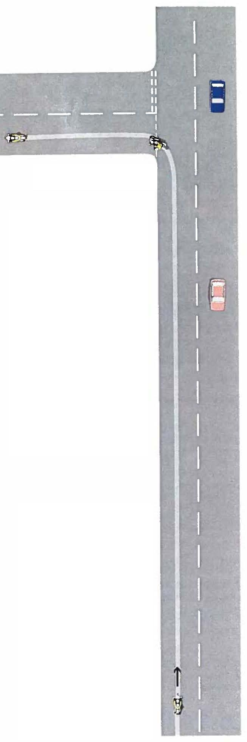

**Lifesaver here.**

**Information**

Identify hazards.

Scan to the front, rear and sides to gather information on the position and intentions of other road users.

**Carry out rear observations before you make any change in speed or direction**.

Examine the road surface for anything that could reduce your tyre grip. e.g. petrol, oil or diesel, road paint, tar overbanding, loose dust or gravel.

Be flexible and be prepared to adjust your riding plan to accommodate new hazards.

**Consider giving a signal or sounding your horn at any point where other road users could benefit.**

Remember, other road users include pedestrians, as well as cyclists, motorcyclists and drivers of other vehicles.

**Acceleration**

Be aware of the possibility of cyclists and motorcyclists moving up quickly on your inside.

Use the throttle to maintain your speed and stability through the hazard. Open the throttle sufficiently to offset any loss in speed due to cornering forces.

Taking account of your speed, the road surface, the amount of turn required, other road users and the road and traffic conditions ahead and behind and decide whether it is appropriate to accelerate away from the hazard.

Choose an appropriate point to accelerate safely and smoothly. Adjust the amount of acceleration to the circumstances.

Do not increase speed before you start to return to the upright position. Reference: Roadcraft Chapter 4 - Accelerating on Bends

**Gear**

Select the appropriate gear for the speed at which you intend to negotiate the hazard.

Reference: Roadcraft Chapter 4 – Acceleration, using gears and brakes.

**Speed**

Adjust your speed as necessary using the throttle and brakes or, when necessary to avoid skidding, gears to give you the speed which will enable you to complete the manoeuvre.

During the later stages of braking change to the appropriate gear.

Make good use of acceleration sense.

A left turn is generally slower than a right due to a tighter turning arc. Avoid running wide as you enter the junction or you may come into conflict with other traffic.

**Position**

Move into the appropriate position towards the near side of the road but pay attention to:

* Road width
* Lane markings
* Obstructions
* Road surface and condition
* Position, speed and size of other traffic in front or behind
* Position to be seen
* Ensuring you have a good view
* Making your intentions clear
* Traffic flow

## Applying the System to a Right Hand Turn

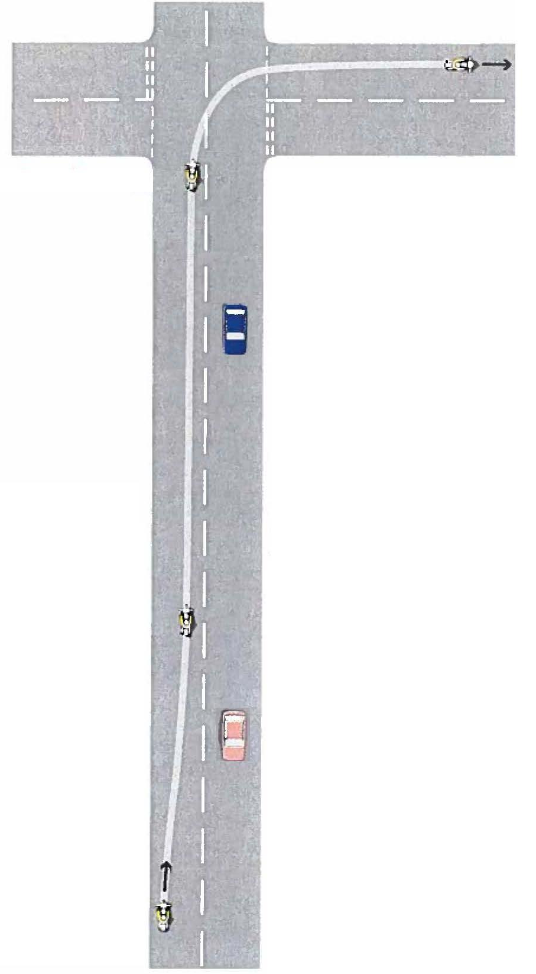

**Lifesaver here.**

**Information**

Identify hazards.

Scan to the front, rear and sides to gather information on the position and intentions of other road users.

**Carry out rear observations before you make any change in speed or direction**.

Examine the road surface for anything that could reduce your tyre grip. e.g. petrol, oil or diesel, road paint, tar overbanding, loose dust or gravel.

Be flexible and be prepared to adjust your riding plan to accommodate new hazards.

**Consider giving a signal or sounding your horn at any point where other road users could benefit.**

Remember, other road users include pedestrians, as well as cyclists, motorcyclists and drivers of other vehicles.

**Gear**

Select the appropriate gear for the speed at which you intend to negotiate the hazard.

Reference: Roadcraft Chapter 4 – Acceleration, using gears and brakes.

**Speed**

Adjust your speed as necessary using the throttle and brakes or, when necessary to avoid skidding, gears to give you the speed which will enable you to complete the manoeuvre.

During the later stages of braking change to the appropriate gear.

Make good use of acceleration sense.

**Position**

Move into the appropriate position towards the off side of the road in good time to make the manoeuvre but pay attention to:

* Road width
* Lane markings
* Obstructions
* Road surface and condition
* Position, speed and size of other traffic in front or behind
* Position to be seen
* Ensuring you have a good view
* Making your intentions clear
* Traffic flow

**Acceleration**

Use the throttle to maintain your speed and stability through the hazard. Open the throttle sufficiently to offset any loss in speed due to cornering forces.

Taking account of your speed, the road surface, the amount of turn required, other road users and the road and traffic conditions ahead and behind and decide whether it is appropriate to accelerate away from the hazard.

Choose an appropriate point to accelerate safely and smoothly. Adjust the amount of acceleration to the circumstances.

Do not increase speed before you start to return to the upright position. Reference:

Roadcraft Chapter 4 - Accelerating on Bends

## Applying the System to a Right Hand Turn At Roundabout

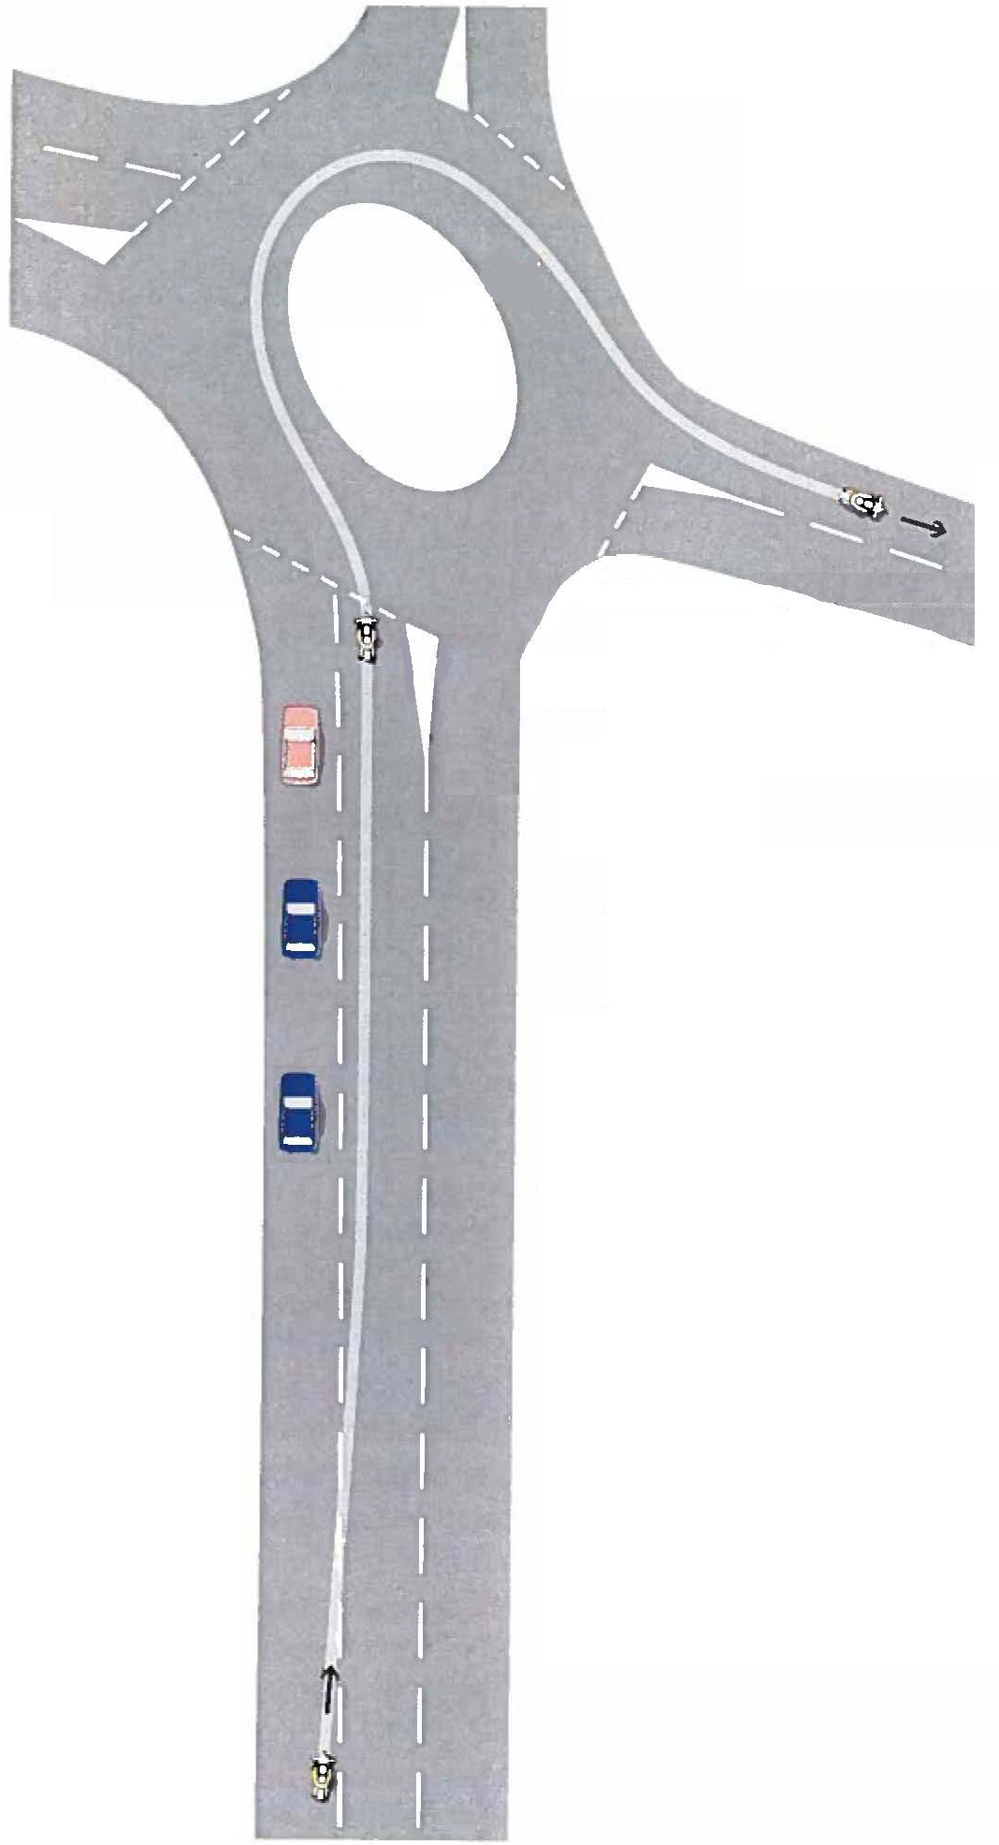

**Lifesaver here.**

**Information**

Identify hazards.

Scan to the front, rear and sides to gather information on the position and intentions of other road users.

**Carry out rear observation before you make any change in speed or direction**.

Decide early which exit to take and in which lane to approach the roundabout.

Examine the road surface for anything that could reduce your tyre grip. e.g. petrol, oil or diesel, road paint, tar overbanding, loose dust or gravel.

Be flexible and be prepared to adjust your riding plan to accommodate new hazards.

**Consider giving a signal or sounding your horn at any point where other road users could benefit.**

Remember, other road users include pedestrians, as well as cyclists, motorcyclists and drivers of other vehicles.

Keep alert for an early view of traffic both on the roundabout and approaching it from other entrances.

**As you approach the roundabout be prepared to stop, but look for the opportunity to go.**

**Acceleration**

Choose an appropriate gap in the traffic to accelerate safely and smoothly onto and through the roundabout without disturbing the traffic already using it.

**Gear**

Select the gear to proceed onto the roundabout.

This will depend on your speed, the traffic conditions and your machine’s characteristics.

**Speed**

Lose speed smoothly, using either deceleration or brakes.

Systematically work through the gears as you slow down, or block change to the appropriate gear just before the end of braking.

Your approach speed will be determined by your view of the roundabout and the traffic using it.

**Plan to stop, but look to go.**

**Position**

Your approach position will depend on which exit you intend to take, the number of approach lanes and the lane markings. (see Highway Code).

The route through the roundabout will depend on the presence of other traffic and on the road surface.

The best route is generally the shortest route between entry and exit.

Before you change position consider rear observation.

When you are on the roundabout, deal with any new hazards by using the appropriate phases of the system.

Consider rear observation to both sides on exiting the roundabout.

**Lifesaver here.**

**INFORMATION, OBSERVATION and ANTICIPATION**

Good ‘Observations’ require using your senses of sight, hearing and smell to obtain as much information as possible about the environment and conditions you are riding in.

This is a key element in advance / defensive riding because if you’re not aware of a particular hazard then you can’t plan and react for it.

Your ability to take, use and give information while applying the system of motorcycle control depends on your skills of observation and planning.

Observations: Use your eyes to constantly scan the environment around you

from the far, middle and near distance and to the sides and rear.

Check the mirror where the zone of greatest danger lies last.

i.e. nearside when turning left but use them flexibly.

Planning: The purpose of a riding plan is to put you in the correct position, at the

right speed, in the right gear and at the right time to negotiate the hazard safely and efficiently.

To gain a safe and effective riding plan we must:-

**Anticipate**: What we can’t see and what we expect to happen.

**Prioritise**: Grading the hazards in order of importance.

**Decide**: Finalise our decisions.

Since the environment is constantly changing as we ride, so too must our riding plans. Effective planning is a continual process of forming and re-forming plans.

A good riding plan takes into account; what can be seen, what can’t be seen and what circumstances can reasonably be expected to develop. It should also include a ‘back-up plan’.

Always ride at a speed at which you are confident and competent and which will allow you to stop safely and in a controlled manner on your own side of the road, in the distance you can see to be clear, day or night.

The statutory maximum speed limit is not necessarily the safe speed.

**ANTICIPATING HAZARDS IN THE RIDING ENVIROMENT**

Riding at night or in poor weather conditions presents a number of additional hazards for consideration in our riding plans and these are explained in this section of Roadcraft.

Observation links are clues to the likely actions of other road users and greatly assist in the formation of good riding plans. Your ability to anticipate hazards and the use of observation links develops by training and experience. You should aim to increase your knowledge of observation links and a number of them have been included at the end of the guide for reference.

**RIDER’S SIGNALS**

The purpose of signals is to inform other road users of your presence or intentions and a signal should be given whenever it could benefit other road users.

**Do not signal indiscriminately.**

A signal can be given at any point in the system but if required at phase 1 it should be given prior to any change in road position.

**Signalling does not give you a right to carry out the indicated actions.**

**POSITIONING**

**Road Positions**

**Central:** A position that is equidistant from the nearside kerb line and the road centre line.

**Nearside:** A position approximately 25 cm - 45 cm out from the kerb, kerb-shy

line or verge.

**Offside:** A position approximately 25 cm - 45 cm in from the centre or imaginary centre line.

**Opposing:** A position which is across the centre, or imaginary centre line.

**Safety:** A positionwhich provide the greatest margin of safety in a given situation. **All other positions for view may have to be sacrificed for safety.**

To take in all the information that is available you need to position your machine appropriately and this applies equally to roads subject to lower speed restrictions (30, 40 and 50) as it does to roads subject to the national speed limit. You must consider on the approach to a hazard if your position provides the best view whilst retaining appropriate safety margins? **We must never sacrifice safety for view.** While you can assist other road users by making sure they can see you, you must also ensure that you do not confuse them by your position or movements.

***In built up areas it is advisable to adopt a central position unless you are moving out for a view, or the road surface and / or traffic conditions dictate otherwise.***

***On roads subject to the national limit it is advisable to adopt an offside position riding close to the centre line unless the road surface and / or traffic conditions dictate otherwise. While riding in an offside position you must be aware of the oncoming traffic and adjust your position to the centre or nearside dependant on the road width and type / volume of the oncoming traffic.***

***On Motorway / Dual Carriageway it is advisable to ride in a central position in your chosen lane unless circumstances dictate otherwise*.**

**ACCELERATING, GEARS & BRAKING**

The smoothness of a ride is greatly improved by the early anticipation of the need to slow down or stop and by slowing gently and progressively.

**Acceleration Sense**

The ability to vary machine speed in response to changing road and traffic conditions by the accurate use of the throttle. The essence of acceleration sense is good observation, coupled with sound judgement of speed and distance.

**Braking Sense**

The ability to appreciate a situation correctly, and to apply the brakes in a timely and gradual manner (other than in an emergency) to stop or reduce the speed of the machine when this cannot be achieved by deceleration in the time and distance available to the rider.

***Rear observations must be made prior to any change in speed or direction***

Skilful use of the gears depends on the ability to select the most suitable gear for the current road / traffic conditions. In general, the most appropriate gear is one which allows the engine to operate within the middle section of its power / rev range to provide a positive response to throttle changes.

Avoid selecting a lower gear instead of the brakes to slow the machine down.

***Following Position***

When behind another vehicle and there is no intention to immediately overtake, the rider of the following vehicle should ensure that they maintain a good view of the road ahead and a minimum distance behind the vehicle ahead of:

* A two second time gap or
* A gap of one foot per mile per hour at speeds up to 30 mph and one yard per mile per hour at speeds over 30 mph.

In poor weather conditions the above distance must be significantly increased to at least double in wet conditions and at least 10 times in icy conditions.

**CORNERING, BALANCE & AVOIDING SKIDS**

Cornering is an area where a misjudgement could result in a major incident. It is therefore imperative that the rider fully understands the **Key Principles for Safe Cornering** and the use of the **Limit Point**.

**Key Principles for Safe Cornering**

Applying the system and the safe stopping rule gives us five key principles of safe cornering:

1. Be in the right position on the approach.
2. Be travelling at the right speed for the corner or bend.
3. Have the correct gear engaged for that speed.
4. Be able to stop in the distance they can see to be clear on your own side of the road.
5. Have the throttle open to maintain a constant speed round the bend i.e. maintain a positive throttle.

**Cornering Position Advantages**

By positioning correctly for right and left hand bends the advantages to be gained are:

* An earlier and more extended view is made available as you approach and negotiate the corner, thereby enabling you to plan your ride earlier.
* An enlarging of the turning circle of the motorcycle which reduces the likelihood of the motorcycle skidding, it being realised that the tendency of a motorcycle to skid is always greater when completing a small turning circle than negotiating a large one.

**Positioning**

When approaching and negotiating any bend the rider must position the vehicle safely and on their own side of the road, whilst trying to obtain the best view of the road ahead. Therefore the best position available for negotiating a left-hand bend is **offside** and a right hand bend is **nearside.**

This being said these positions should only be occupied when there is clear advantage to be gained – i.e. the road is sufficiently wide to allow for a significant movement to the nearside or offside. Before taking up any position consideration must also be given to the nearside and offside dangers

**Note –** As a general rule the above cornering positions are not adopted in 30 and

40 mph limits or on Motorway / Dual carriageways unless you are moving out for

a view or road surface and / or traffic conditions dictate otherwise.

## Limit Point

The limit point is the furthest point along the road to which you have an uninterrupted view and is where the nearside and offside verges appear to meet. The speed and direction of this point is important because it helps determine the severity of the bend.

On approaching the bend, the limit point will either:

* Remain stationary or move closer – indicating that the bend is severe and the vehicle must lose speed.
* Move away – indicating that the bend is opening and it is safe to proceed. The speed at which the limit point moves away dictates the speed at which the vehicle may pass around the bend. However, this is not necessarily the safe speed for the bend and you must always ensure that you can stop within the distance you can see to be clear.

## Riding through a series of bends (Trimming)

With good observation and planning you can ride through a series of bends by linking the exit of one corner with the entry of the next thereby allowing you keep the machine as upright as possible. While trimming however, care must be taken not to cross the road centreline.

Trimming equally applies to roundabouts. Where the road surface has lane markings, you should seek the straightest line through the roundabout without crossing lanes. Where the road surface has no lane markings then the straightest route from entry to exit across the roundabout should be sought. You must however, be aware of the position, speed and direction of other vehicles on or approaching the roundabout.

**OVERTAKING**

Overtaking places you in a zone of potential danger and requires good judgement if it is to be executed safely. Always be patient and leave a good margin of safety.

**If you are in any doubt, hold back. Overtaking is your decision and you can always reconsider it at any point.**

There are two specific overtaking situations:

* When the absence of other hazards allows you to approach and overtake in one manoeuvre.
* When other hazards require you to take up a **following position** before you can overtake.

In the following position you should observe and assess the road and traffic conditions and identify where there may be an opportunity to overtake safely. You need therefore to consider the following:

What will be the likely response of the driver and occupants of the vehicle in front ?

What is the speed of the vehicle(s) to be overtaken ?

Are the drivers in front aware of your presence ?

Are the drivers ahead likely to overtake ?

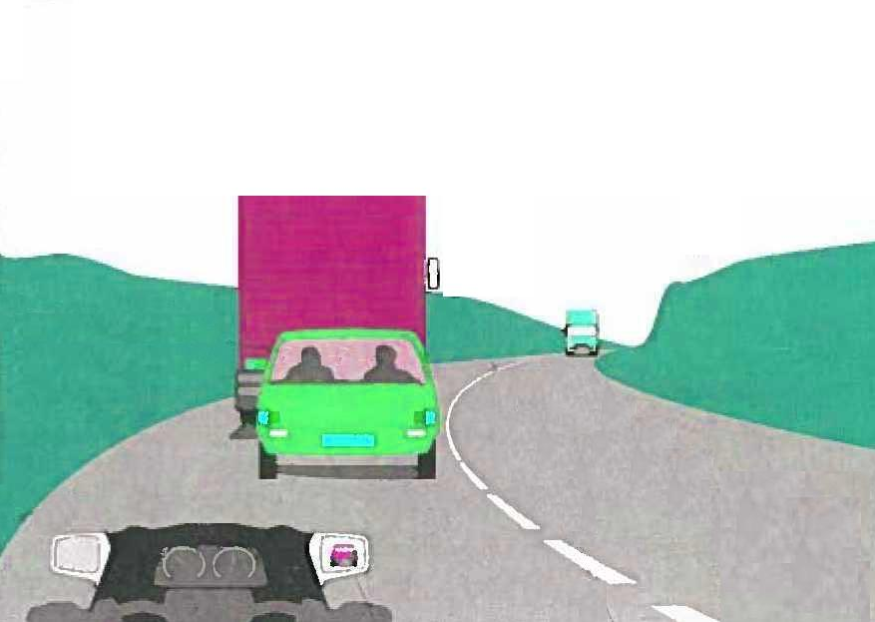

Does the road layout present a hazard ?

Is there a possibility of as yet unseen vehicles approaching at high speed ?

Have you taken into account the relative speed and performance of your own machine ?

What is happening behind ?

Are any of the drivers behind likely to overtake you ?

What is the speed of approaching vehicles in view ?

What is the distance needed to overtake and regain a nearside gap safely ?

**Basic rule for overtaking**

* Identify the gap into which you can return and the point along the road at which you will be able to enter it.
* Ensure that you can reach and enter the gap before any approaching vehicles, seen or unseen, could come into conflict with you.

Coming into conflict includes causing other road users to alter speed and / or direction, or for them to be concerned for their own safety.

**MOTORWAY RIDING**

Safe motorway riding involves the careful application of the skills and methods covered in all the other chapters of Roadcraft together with an awareness of the additional hazards that arise from increased speed and traffic volume.

While this section refers to ‘motorways’ it is equally applicable to dual carriageways.

Safe motorway riding is dependant on:

* Extended and frequent observations to the front, side and rear.
* Early anticipation of the movement of others.
* Maintaining a safe following distance at all times.
* Signalling your intentions early and giving others time to react to your signal prior to you making your manoeuvre.
* Checking your speed regularly, especially when leaving the motorway.
* Maintaining good lane discipline at all times.
* Making allowances for cross-winds and turbulence caused by large vehicles.

When intending to join these roads from a slip road with more than one lane you should generally, dependant on traffic conditions, use the one which gives you the best view of the main carriageway. Use this view and acceleration sense to give you the correct speed to merge with the traffic on that carriageway smoothly and safely.

On the carriageway remember that speeds are generally higher than other roads and allow an appropriate following distance. When planning to leave the motorway allow time to get into lane 1 without having to ‘cut across’ other vehicles.

When joining, overtaking or leaving such roads consider a signal as required to inform other road users of your intentions.

THOUGHT PROCESSES USING THE SYSTEM FOR COMMOM HAZARDS

Based from a ‘central’ position on a two-way, undivided

single carriageway road unless specified otherwise

A key point to remember about the system is **flexibility,** it is not an automatic mechanism but must be adapted to the circumstances as they arise, intelligently and responsively. It should be noted that not all road junctions / hazards are the same and those which present an acute angle, fast moving traffic or a limited view, then a reversal of final mirror checks should be considered. **Always check the area of the greatest danger last.**

Left-turn from main road no signal required

Offside mirror, nearside mirror, my position will be to the nearside, reducing speed my gear is ?, nearside mirror, left lifesaver, applying a light degree of acceleration to leave the hazard safely.

**Left-turn onto main road signal required at phase 1 - stopping**

Offside mirror, nearside mirror, signalling left my position will be to the nearside, reducing speed bringing my vehicle to a halt before the give way / stop line. My gear is one, offside mirror, nearside mirror, left lifesaver *(or alternatively subject to the nature of junction, refer key point above, nearside mirror, offside mirror, right lifesaver),* applying a light degree of acceleration to leave the hazard safely.

**Right-turn from main road no signal required**

Nearside mirror, offside mirror, my position will be to the offside, reducing speed my gear is ?, offside mirror, right lifesaver, applying a light degree of acceleration to leave the hazard safely.

**Right-turn onto main road signal required at phase 1 - stopping**

Nearside mirror, offside mirror, signalling right my position will be to the offside, reducing speed bringing my vehicle to a halt before the give way / stop line. My gear is one, nearside mirror, offside mirror, right lifesaver *(or alternatively subject to the nature of junction, refer key point above, offside mirror, nearside mirror, left lifesaver),* applying a light degree of acceleration to leave the hazard safely.

**CROSSROADS**

**Straight ahead at crossroads**

Offside mirror, nearside mirror, my position will be central, reducing speed bringing my vehicle to a halt before the give way / stop line. My gear is one, nearside mirror, offside mirror, right lifesaver, applying a light degree of acceleration to leave the hazard safely.

**ROUNDABOUTS**

**Straight ahead at roundabout**

Offside mirror, nearside mirror my position will be central, reducing speed looking for a gap. I have a gap, speed is correct, my gear is ?, nearside mirror, left lifesaver, applying a light degree of acceleration to the rim of the roundabout. Nearside mirror, left-turn supplementary signal, left lifesaver, applying a light degree of acceleration to leave the roundabout.

**Left-turn at roundabout**

Offside mirror, nearside mirror, signalling left my position will be to the nearside, reducing speed looking for a gap. I have a gap, speed is correct, my gear is ?, nearside mirror, left lifesaver, applying a light degree of acceleration to take me into and clear of the roundabout.

**Right-turn at roundabout**

Nearside mirror, offside mirror, signalling right my position will be to the offside, reducing speed and looking for a gap. I have a gap, speed is correct, my gear is ?, nearside mirror, left lifesaver, applying a light degree of acceleration to the hub of the roundabout. *Then just after the junction prior to yours,* nearside mirror, left-turn supplementary signal, left lifesaver, applying a light degree of acceleration to leave the roundabout.

**Straight ahead at roundabout** (From lane one of dual carriageway / two lane entry)

Offside mirror, nearside mirror, my position is lane one, reducing speed looking for a gap. I have a gap, speed is correct my gear is ?, offside mirror, shoulder check right, nearside mirror, left lifesaver, applying a light degree of acceleration to the rim of the roundabout. Nearside mirror, left-turn supplementary signal, left lifesaver, applying a light degree of acceleration to leave the roundabout.

**Left-turn at roundabout** (From lane one of dual carriageway / two lane entry)

Offside mirror, nearside mirror, signalling left, my position is lane one, reducing speed looking for a gap. I have a gap, speed is correct my gear is ?, nearside mirror, left lifesaver, applying a light degree of acceleration to take me into and clear of the roundabout.

**Right-turn at roundabout** (From lane two of dual carriageway / two lane entry)

Offside mirror, nearside mirror, signalling right, my position is lane two, reducing speed looking for a gap. I have a gap, speed is correct, my gear is ?, nearside mirror, left lifesaver, applying a light degree of acceleration to the hub of the roundabout. *Then just after the junction prior to yours, n*earside mirror, left-turn signal, left lifesaver, applying a light degree of acceleration to leave the roundabout.

*On large multi-lane and spiral roundabouts, particularly those with ‘dual carriageway’ exits, then consideration should be given for an offside mirror check, prior to carrying out a nearside mirror check just after the junction prior to yours. Refer to key point regarding system flexibility.*

**PEDESTRIAN CROSSING**

**No pedestrian activity**

Nearside mirror, offside mirror, my position will becentral. Scanning the crossing left to right – right to left, the crossing is clear and it’s safe to proceed.

**Pedestrians at or near to crossing but lights are green**

Offside mirror, nearside mirror my position will becentral. Reducing speed, check lights are green and that it’s safe to continue. Speed is correct, gear is ?, nearside mirror, offside mirror, applying a light degree of acceleration to leave the hazard safely.

**Pedestrians at or near to crossing but lights are red or changing to red.**

Offside mirror, nearside mirror my position will becentral. Reducing speed, bringing vehicle to a halt at the stop line / behind the vehicle in front.

Lights are about to change / are changing, my gear is one, nearside mirror, offside mirror, right lifesaver, applying a light degree of acceleration to leave the hazard safely.

**CORNERS / BENDS ON OPEN ROAD**

**Left-hand bend (No speed correction)**

Offside mirror, position will beoffside and watching the limit point. The limit point **is moving away** quickly therefore my speed is correct. Gear is ?, applying sufficient throttle to maintain a constant speed through the bend.

**Right-hand bend (Speed correction)**

Nearside mirror, position will be nearside and watching the limit point. The limit point ***is not*** moving, reducing speed. The limit point **is now moving away** quickly therefore my speed is correct. Gear is ?, applying sufficient throttle to maintain a constant speed through the bend.

**SPEED LIMIT CHANGE**

**On the approach to a higher speed limit sign**

Nearside mirror, offside mirror, no following vehicles are about to overtake, the road ahead is clear, then as my vehicle passes between the signs I will apply a suitable degree of acceleration up to the higher speed limit.

**On the approach to a lower speed limit sign**

Offside mirror, nearside mirror, my position is ?, there are / are no following vehicles, speedometer check indicates the need to lose speed, consider need for a brake warning light, reducing speed by acceleration / braking sense to achieve the posted speed as my vehicle passes between the signs.

**ROADSIDE OBSTRUCTIONS**

**Parked vehicles / roadworks etc:**

Nearside mirror, offside mirror, my position is offside / safety to avoid the obstruction, consider reducing speed, gear is ?. An early and gradual deviation eliminates the need for a signal.

If you are likely to come into conflict with opposing vehicles or pedestrians then a ‘full straight ahead’ system should be used. A typical example based on passing a parked vehicle with occupants on the nearside with on coming vehicles would be:

Nearside mirror, offside mirror, consider signal, position is offside / safety, reducing speed, speed correct, gear is ?, offside mirror, nearside mirror, my position is central, applying a light degree of acceleration.

**Observation links**

An observation link is a technique that allows an advanced rider to anticipate the hazards they are likely to meet at any given time. Reaction speed is up to three times faster to a hazard that is expected than one which is not.

|  |  |
| --- | --- |
| **Observation** | **Expectation** |
| Empty bus stop. | You are on a bus route so can expect to meet a bus. |
| The bus is possibly travelling in front of you. |
| A bus driving ahead of you. | Look out for people getting up from their seats - the bus may stop. |
| Look for pedestrians on the other side of the road, they may try to cross the road to catch the bus. |
| A bus stop where a bus is waiting. | Pedestrians stepping out onto the road from in front or behind the bus. |
| It may just pull out on you, be prepared to give way (highway code). |
| If the last person is stepping on to the bus, expect the bus to pull away at any moment. |
| Pedestrians running across the road to get on the bus. |
| A bus stop on the opposite carriageway where a bus is waiting. | Pedestrians stepping out onto the road from in front or behind the bus. |
| Pedestrians running across the road to get on the bus. |
| On coming vehicles may overtake the bus. |
| People waiting at a bus stop  (particularly elderly people). | A bus is expected and is possibly travelling behind you or approaching you. |
| A vehicle with foreign number plate. | Overseas driver who may be concentrating on the scenery / map / directions and not the road. |
| Driver may not be aware of our traffic rules. |
| A green traffic light. | May change to RED. |
| Delivery van in town. | Could be about to stop. |
| Driver under instruction / learner driver. | They may do something unexpected. |
| Someone behind them may decide to overtake. |
| Driver using mobile phone / headset. | They will not be concentrating as well as they should and not aware of your presence. |
| Large vehicle ahead starts to signal left. | It is likely to swing out to the right before turning. |
| Industrial premises. | Associated vehicles and access roads. |
| Telecom / Gas board / Water board vehicles. | Other company vehicles as they often work in pairs. |
| Line of trees, houses, lamp standards. | Gives you the line of intending road (i.e. the road may comes back from the right, as suggested by the line of the trees). |
| Wheelie bins out on the pavement. | The bin lorry working in the area. |
| Street lamps lit during the day. | Tower wagons and other maintenance vehicles in the area. |
| **Observation** | **Expectation** |
| Petrol station. | Vehicles entering / emerging and contamination of the road surface with fuel spillage. |
| A cyclist ahead. | Cyclist may quickly veer towards a junction or driveway on the right - so look for them. |
| Cyclist may swerve at the last moment for a drain or pothole in the road - scan the road just ahead of the cyclist. |
| Cyclist may 'wobble' . Especially on a windy day or going uphill. |
| A pedestrian with dog on the pavement. | Animal may get frightened and jump onto the road. |
| A child on the pavement. | May run out without notice. |
| May run to other children across the road (look for them). |
| Play parks. | More children around. |
| High hedges. | Children running out from entrances which may be concealed from view. |
| Pillar box. | Pedestrians and mail vans. |
| Shops. | Delivery vehicles, pedestrians etc. |
| Pedestrian crossing has illuminated 'wait' signal. | The traffic lights may be about to change. |
| Pedestrians waiting at crossing. | The traffic lights may be about to change. |
| A cross view over fields you see rooftops. | Speed limits as you enter a village. |
| A cross view over fields you see a cluster of lampposts. | You are probably heading towards a roundabout. |
| A cross view over fields you see a vehicle coming quickly from the left or right. | Your road will bend sharply just ahead. |
| A hidden junction or roundabout ahead. |
| A cross view over fields you see a large Heavy Goods Vehicle. | Other vehicles will be trying to overtake it. |
| Line of trees at 2 o’clock or 10 o’clock position. | Indication of a junction or roundabout ahead. |
| Cross flow of traffic in 2 o’clock or 10 o’clock position. | Indication of a junction or roundabout ahead. |
| No gap in a bank of trees directly ahead. | The road curves either left or right. |
| Edges of the road churned up / tyre marks. | Vehicles have possibly had to go on the verge to pass each other, especially if wider vehicles use that road. |
| Name of a village - In a National Speed Limit. | Expect a 30 mph limit round the corner. |
| Road with damaged verges. | Heavy traffic uses the road - watch out for lorries. |
| Fresh mud tracks turning left from a field exit. | Tractor ahead. |
| No footpath / pavement beside a country road. | Pedestrians or ramblers in the road. |
| Fresh manure on country road. | Animals, horse / cattle on road ahead. |
| **Observation** | **Expectation** |
| Overgrown vegetation on pavement. | Pedestrians could be forced into the road to pass. |
| Poor or no roadside fencing in rural area. | Animals in the road. |
| Farm dwellings. | Access to house, tractors and mud deposits on the road. |
| A hedge row at right angles to the road. | Possible junction up ahead. |
| While driving in a rural area you see an area of habitation. | Speed regulatory at or near the first lamp post or building. |
| Traffic ahead of you is slowing / stopping. | Possible vehicle turning right. |
| Vehicles, pedestrians, animals etc in front of him. |
| Agricultural vehicles working in nearby fields. | Mud or grass deposits on the road. |
| Tractors coming towards you. | Possible vehicle could be about to overtake it. |
| Vehicle with flashing amber light ahead. | Slow tractor / hedge cutter / road works. |
| A pedestrian leading animals. | Animal may get frightened and jump or cross over the road. |
| One high-speed motorcycle riding recklessly. | Another motorcycle riding likewise close behind. |
| ‘H’ Hospital  (Particularly one for A & E). | Emergency vehicles entering / exiting. |
| Possibility of distressed drivers entering / exiting the hospital. |
| Roadworks. | Possibility of poor road surface conditions due to dirt / gravel / water etc being on the road. |
| Unmarked police motorcycles operating in this area. | Road is challenging and other motorcyclists may be riding beyond their limits. |
| Speed / Safety Camera Sign. | Accident black spot area. |
| A vehicle pulls up opposite a school entrance. | Doors may open. |
| School sign. | Vehicles stopping to drop off or collect kids. |
| Children / people may step into the road without looking. |
| Look for the school gates and crossing patrol. |
| Traffic Calming Scheme. | Possible speed limit change not too far down the road. |
| Diversion signs. | Confused and hesitant motorists. |
| Height restriction sign at a bridge. | Larger vehicles could be approaching in the centre of the road.  Debris on the road surface. |
| Warning of low flying aircraft. | Beware of sudden loud noise. |
| Temp sign for a big event  (A festival etc). | Expect people to do stupid things to avoid the traffic. |
| Expect traffic queues in the middle of nowhere. |
| Parking sign, Car Park. | Vehicles pulling out from seemingly nowhere, particularly underground or multi-storey car parks in city centres. |
| Contamination of the road surface with fuel spillage. |
| **Observation** | **Expectation** |
| Traffic cones or barriers on the road. | There may be men at work on the road. |
| Drive on the left sign. | Overseas driver who may be concentrating on the scenery / map / directions and not the road. |
| Driver may not be aware of our traffic rules. |
| Yellow paint highlighting road surface irregularities. | The possibility of meeting road repair works in the area. |
| Information sign for housing development. | Heavy construction traffic or mud deposits. |
| Worker holding ‘Stop n Go’ sign. | May turn sign to ‘Stop’ at the last minute. |
| Manhole covers in the road. | Expect more – they follow the drainage trench. |
| Recent resurfacing work | Take care because they don't always sweep the roads of gravel straight away. |
| Road surface looks much blacker than normal. | Expect large puddle of still water or black ice. |
| Shady area in winter. | Damp / Ice patches (micro-climate). |
| Cars parked by a Burger / Fish & Chip / Ice Cream van. | Pedestrians / Children crossing. |
| Brake lights lit on parked vehicle. | Vehicle may be about to pull out without signalling. |
| Driver sat in a parked car. | May open door without checking behind them first. |
| Interior light comes on in parked car ahead. | Door about to open wide. |
| Taxi at side of road. | May do a U-turn without looking. |
| A car pulls in up ahead. | Watch out for doors opening. |
| A vehicle pulls up at the side of the road or stops in an entrance. | Maybe about to do a U turn. |
| Door may about to be opened. |
| A vehicle pulls up and reverses into a side road or entrance. | It may promptly come out again and drive off in the opposite direction. |
| Royal Mail parked van. | Postal worker crossing road. |
| Dwelling houses in built up area. | Vehicles entering or reversing onto carriageway from driveways. |
| Green traffic lights showing at junction. | Green traffic lights may change. |
| Under axle view of parked vehicles. | Foot or leg movements of pedestrians about to emerge (especially children). |
| Fire Service vehicle with blue lights and sirens. | Look and listen for another (especially at junctions).They usually attend calls in pairs. |
| White lines in the centre of the carriage way are worn with wide tyre markings on them. | Look out for vehicles cutting the corner. |
| Look out for HGV's straddling the lines. |
| Large vehicles using that road. |

|  |  |
| --- | --- |
| **Observation** | **Expectation** |
|  |  |
|  |  |
|  |  |
|  |  |
|  |  |
|  |  |
|  |  |
|  |  |
|  |  |
|  |  |
|  |  |
|  |  |
|  |  |
|  |  |
|  |  |
|  |  |
|  |  |
|  |  |
|  |  |
|  |  |
|  |  |
|  |  |
|  |  |
|  |  |
|  |  |
|  |  |
|  |  |
|  |  |

RoSPA Advanced Te Test Criteria

The grade decided by the examiner will not be changed although any appeal will be reviewed by the Chief Examiner, who may offer a retest or comment in writing on any points raised.   
Examiners operate under strict national guidelines to ensure that the Association's very high standards are maintained. The following guidelines about the requirements for each grade are intended to help you understand better the criteria applied when awarding a grade.

|  |
| --- |
| **Gold** |
| This grade is recognised as the highest riding award available to the public. It will be awarded only to the polished systematic rider, who displays a complete understanding and appropriate application of the principles outlined in Motorcycle Roadcraft. The candidate will display a confidence and ability throughout the whole test which leads the examiner to consider that, if afforded the opportunity, the candidate has the potential with the basics already in place to do well on a police advanced course. The candidate's performance must be consistent throughout the whole of the test and so any lapses may result in a lower grade. Awards of this grade will therefore be reserved for the very best riders. |
| **Silver** |
| This grade will be awarded to riders who are well above the average. These riders will produce consistently safe and systematic rides but perhaps without the final polish, flair and smoothness of the Gold riders. They will demonstrate a thorough knowledge of the system of motorcycle control. Candidates must be able to ride up to the permitted speed limit where it is safe to do so but vary speed according to circumstances and conditions. It must be emphasised that silver is an extremely high grade and a commendable achievement. |
| **Bronze** |
| This grade will be awarded to riders whose performance is significantly above the standard required to pass the 'L' riding test. These riders will show a basic knowledge of Motorcycle Roadcraft but lack the ability to apply the system consistently throughout the test. The ride should be entirely safe, observing traffic signs, responding correctly to hazards and should display advanced riding techniques. |

Candidates who fall below the minimum pass will be classified as 'fail'.  
Once you have passed your test, you will be required to maintain your standard of riding by taking a re-test every three years – this is free to Members. When your retest is due we will send you a reminder and booking form. You must take your retest within a reasonable time of the due date in order to keep your Membership.   
Possible reasons for not passing the test or for a lower grade  
Riders will fail if they display potentially dangerous faults, persistently infringe speed limits, commit violations of Road Traffic Law or the rules contained in The Highway Code. If the candidate fails to reach the pass standard, the examiner will offer advice on improvement and encourage further training or guidance from a local group.

Occasional minor infringements with a perceived acceptable reason should not result in failure on their own, but may be a reason for a lower grade. As a general rule, the examiner will consider whether the candidate is a rider worthy of displaying the badge of an advanced rider, i.e. someone who will consistently drive according to the principles of Roadcraft.

|  |
| --- |
| **Notes** |
|  |
|  |
|  |
|  |
|  |
|  |
|  |
|  |
|  |
|  |
|  |
|  |
|  |
|  |
|  |
|  |
|  |
|  |
|  |
|  |
|  |
|  |
|  |
|  |
|  |
|  |
|  |
|  |



**Contact Information**

**Email :**

[**yardenquiries@gmail.com**](mailto:Bikers.ekgroadar@gmail.com)

**Web Site :**

[**http://yard-advanced.org**](http://reivers-advanced.org/)

**Facebook :**

**https://www.facebook.com/groups/EYARD/**